# Question

Given an integer n, return *all the structurally unique****BST'****s (binary search trees), which has exactly*n*nodes of unique values from* 1 *to* n. Return the answer in **any order**.

**Example 1:**

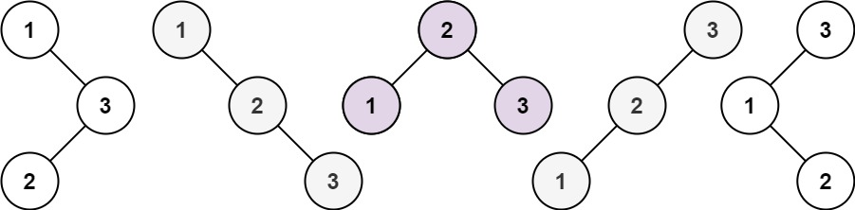

**Input:** n = 3

**Output:** [[1,null,2,null,3],[1,null,3,2],[2,1,3],[3,1,null,null,2],[3,2,null,1]]

**Example 2:**

**Input:** n = 1

**Output:** [[1]]

**Constraints:**

* 1 <= n <= 8

# Solution

**Tree definition**

First of all, here is the definition of the TreeNode which we would use.

|  |
| --- |
| // Definition for a binary tree node.  public class TreeNode {  int val;  TreeNode left;  TreeNode right;  TreeNode(int x) {  val = x;  }  } |

#### **Approach 1: Recursion**

First of all let's count how many trees do we have to construct. As you could check in [this article](https://leetcode.com/articles/unique-binary-search-trees/), the number of possible BST is actually a [Catalan number](https://en.wikipedia.org/wiki/Catalan_number).

Let's follow the logic from the above article, this time not to count but to actually construct the trees.

**Algorithm**

Let's pick up number i out of the sequence 1 ..n and use it as the root of the current tree. Then there are i - 1 elements available for the construction of the left subtree and n - i elements available for the right subtree. As we [already discussed](https://leetcode.com/articles/unique-binary-search-trees/) that results in G(i - 1) different left subtrees and G(n - i) different right subtrees, where G is a Catalan number.

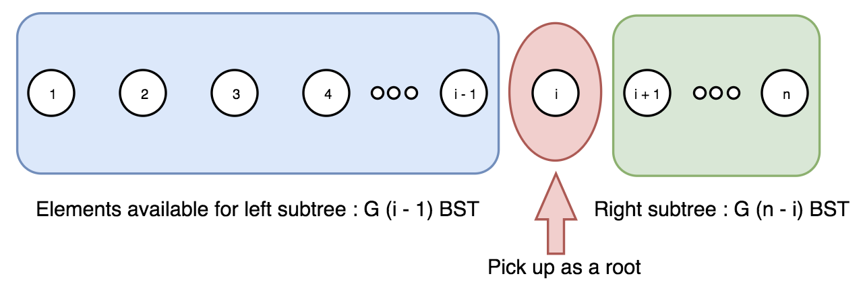

Now let's repeat the step above for the sequence 1 ... i - 1 to construct all left subtrees, and then for the sequence i + 1 ... n to construct all right subtrees.

This way we have a root i and two lists for the possible left and right subtrees. The final step is to loop over both lists to link left and right subtrees to the root.

|  |
| --- |
| class Solution {  public LinkedList<TreeNode> generate_trees(int start, int end) {  LinkedList<TreeNode> all_trees = new LinkedList<TreeNode>();  if (start > end) {  all_trees.add(null);  return all_trees;  }  // pick up a root  for (int i = start; i <= end; i++) {  // all possible left subtrees if i is choosen to be a root  LinkedList<TreeNode> left_trees = generate_trees(start, i - 1);  // all possible right subtrees if i is choosen to be a root  LinkedList<TreeNode> right_trees = generate_trees(i + 1, end);  // connect left and right trees to the root i  for (TreeNode l : left_trees) {  for (TreeNode r : right_trees) {  TreeNode current_tree = new TreeNode(i);  current_tree.left = l;  current_tree.right = r;  all_trees.add(current_tree);  }  }  }  return all_trees;  }  public List<TreeNode> generateTrees(int n) {  if (n == 0) {  return new LinkedList<TreeNode>();  }  return generate_trees(1, n);  }  } |

**Complexity analysis**

